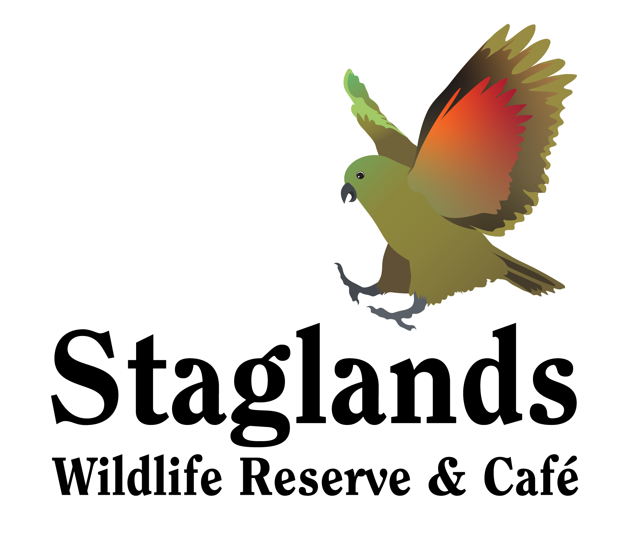

Worksheet for School Students

- Which animal at the Reserve is your favourite? Why?
_______________________________________________________________________________________________________________________________________________________________________________________________________________

- Name a Native animal at the Reserve. What does “Native” mean?
_______________________________________________________________________________________________________________________________________________________________________________________________________________

- Predators kill and eat other animals (their prey). Give an example of a predator/prey relationship at Staglands (ie. Name the predator and state what it preys upon)
_____________________________________________________________________
_____________________________________________________________________
_____________________________________________________________________

- What do birds need to be protected from?
_____________________________________________________________________
_____________________________________________________________________
_____________________________________________________________________

- What is Staglands doing to protect birds?
_____________________________________________________________________
_____________________________________________________________________
_____________________________________________________________________

- Auckland Island Pigs are a rare species. What does this mean?
_____________________________________________________________________
_____________________________________________________________________
_____________________________________________________________________

- Look carefully at the Kaka and the Kea. They are both New Zealand parrots. What similarities do they share?
_____________________________________________________________________
_____________________________________________________________________
_____________________________________________________________________

- Name 3 Staglands animals that are classed as “mammals”. What is a “mammal”? Are people mammals?
_____________________________________________________________________
_____________________________________________________________________
_____________________________________________________________________

- What does “endangered” mean? What happens to an animal to make it “endangered”?
_____________________________________________________________________
_____________________________________________________________________
_____________________________________________________________________

- What is a species?
_____________________________________________________________________
_____________________________________________________________________
_____________________________________________________________________

- What are talons? Where on the body of a bird are they?
_____________________________________________________________________
_____________________________________________________________________
_____________________________________________________________________

- Staglands is 10 hectares. This is the same as 25 acres. How many acres are there in 20 hectares?
_____________________________________________________________________
_____________________________________________________________________
_____________________________________________________________________

- Name an endemic bird. What is the difference between endemic and Native?
_____________________________________________________________________
_____________________________________________________________________
_____________________________________________________________________

